Decromancy Rules

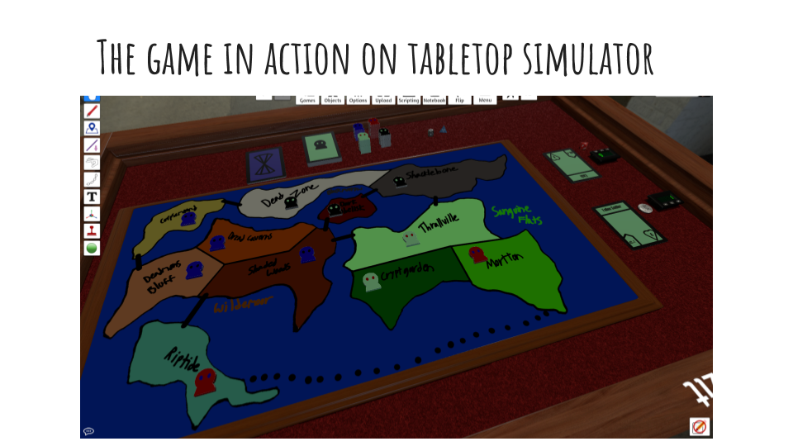

The main goal in Deckromancy is to control all of the locations on the board, it can be played with 2-4 players with stock board size.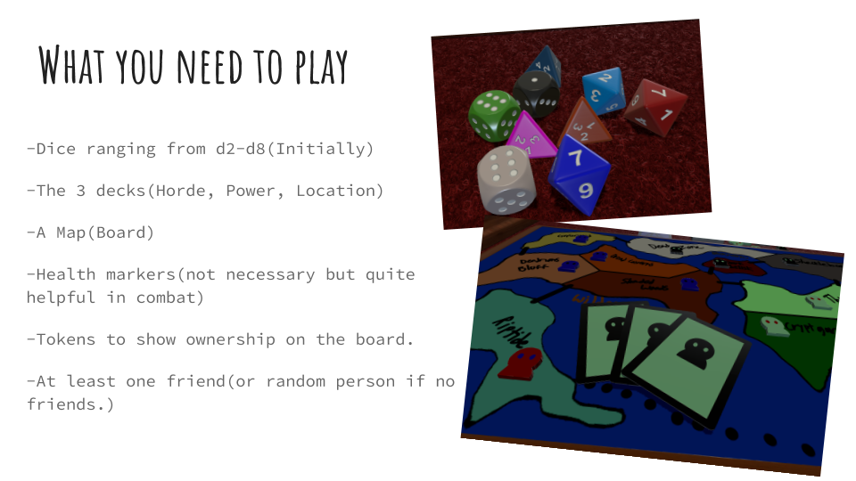

Start of the Game: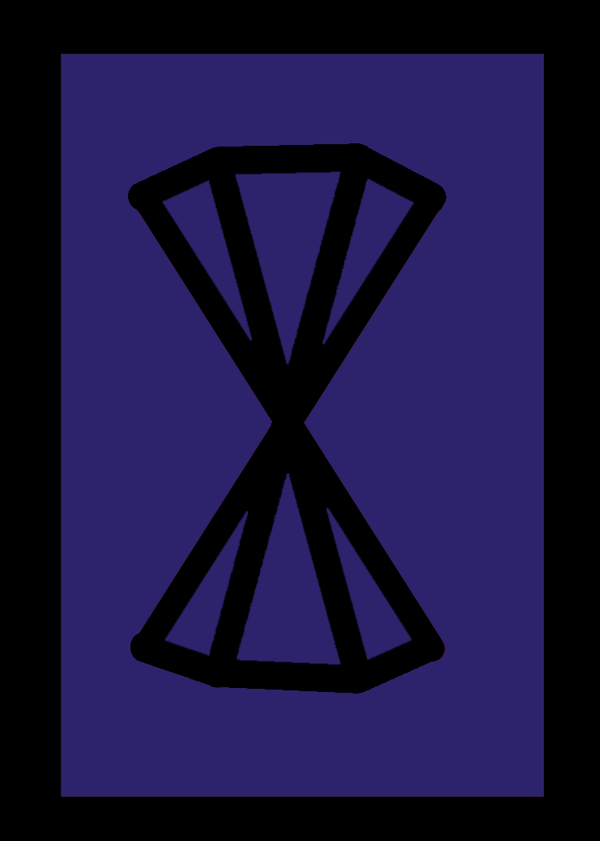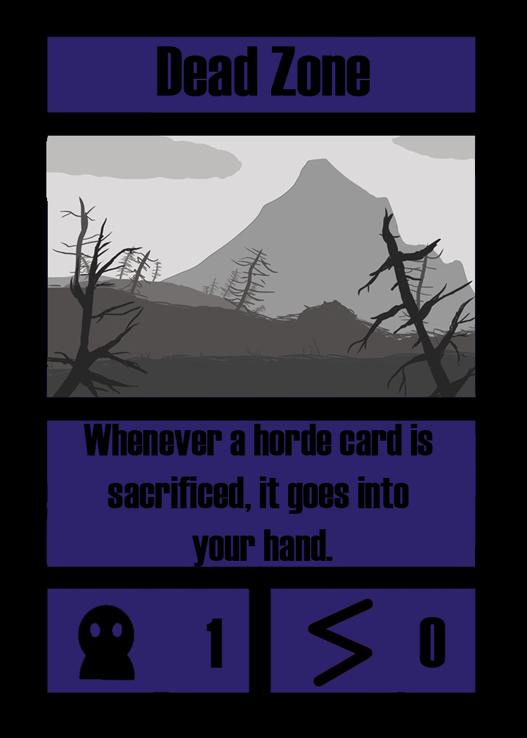

1. Both players randomly draw a location card, if the locations are adjacent then both players draw again until they get non adjacent locations.
2. Players add up the horde and power values of their location, then whoever has the lowest amount goes first, flip a coin in the event of a tie.
3. Player one can then begin their first turn (See Turn Phase)

Turn Phase:

0)Generally, Power cards and Location abilities can be used at any time unless otherwise stated.

1)All players location abilities are refreshed.

2)Player draws 2 power, 2 horde.

3)Player declares one combat if they choose too, it must be to a location from an adjacent location(See Combat Phase).

5)After the player no longer has any actions to take(See Locations and Power Sections respectively) that player discards down to their maximum hand size(equal to their locations horde & power values.) and ends their turn. Play proceeds in a clockwise fashion.

Combat Phase

0)If there is no defender(neutral territory) the attacker simply discards a horde card from their hand and obtains the location card, otherwise, read on.

1)Attacker places one horde card from their hand down, this is their active horde card. Then the defender declares theirs.

3)Both player roll their damage dice and add any modifiers.

4)Both active hordes are assigned damage at the same time equal to the opponents die value plus any modifiers, use tokens or a counter to keep track of health(See Horde Cards for a breakdown of attack/health).

5)The attacker can end combat at any time after damage is assigned, any active hordes return to their owners hands unscathed.

6)The defender may only end combat after their active horde has been killed, they forfeit the location being fought for.

7)If an attacker is victorious they receive the location being fought for and must discard their active horde (if any) if they do not have an active horde and the defender does not have one, then the attacker must discard a horde card from their hand in order to claim the location.

Location Cards:

See the included spreadsheet “Location Cards and Regional Bonuses List” for decklist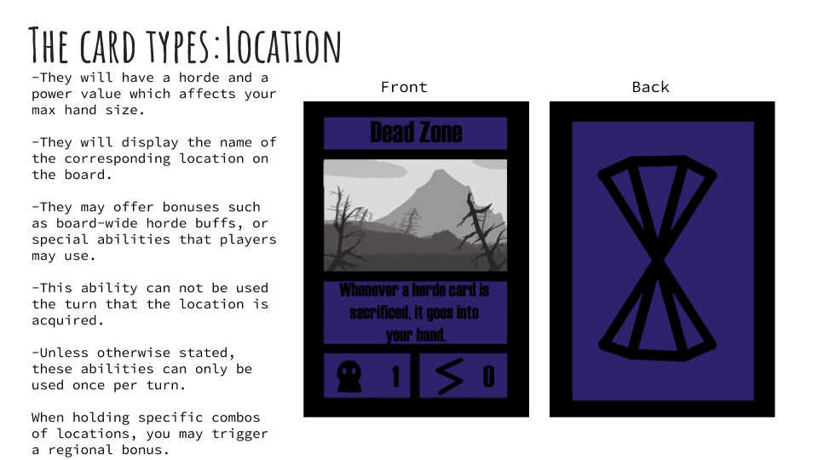

-Max hand size is separate for horde and power.

Power Cards:

See the included spreadsheet “Power Cards List” for decklist

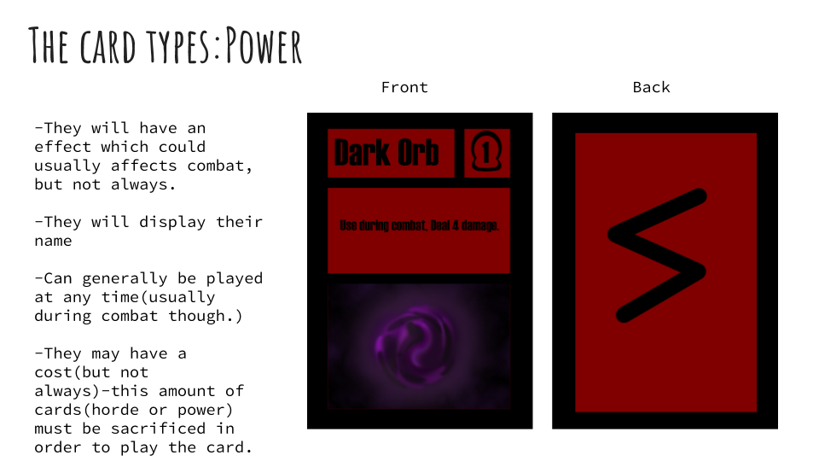

-Sacrifice is the same as discard except it triggers any abilities that use the word sacrifice, discard will not trigger these abilities.

Horde Cards:

See the included spreadsheet “Horde Cards List” for decklist